Spatial subsetting and clipping of MODIS HDF

Purpose
This IDL extension extracts the NDVI layer of an image and applies spatial sub-setting, either by rectangular extent or through a ROI (Region Of Interest) file. It will handle all images with a specific extension from one folder. The output can be stacked (default), and optionally statistics can be calculated for each NDVI layer.
Features:
- Extract the NDVI layer
- Spatially sub-set the NDVI layer by extent or ROI
- Stack the output NDVI layer into a single image, or save to an output folder
- Calculate simple statistics for each NDVI layer (min, max, mean and standard deviation)

Installation
Install the .SAV files and the .PRO file in the save_add folder (see also ENVI .sav files: Installation and configuration.
clip_stack_gui.sav The clipping software
nrs_utils.sav Utility routines
nrsmenu.pro Add menu to ENVI

Usage
Starting is possible from the command line:
clip_stack_gui
, or from the ENVI menu ‘NRS | Clip and stack images’, which starts the following dialog (see below):
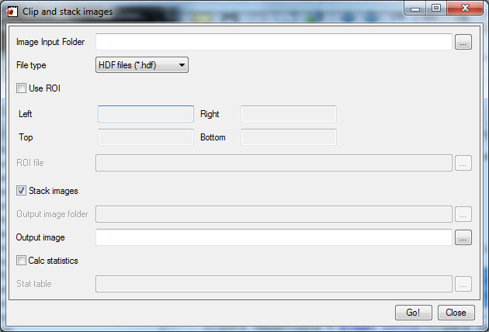
The dialog consists of an input section, and an output section.
The input section has fields to enter the folder containing all the images, to select the file type and to select the extent of the clipping range (either ROI or rectangular extent). When the input folder is selected one of the input files is opened to get the full extent of the images; this may take a while: a progress bar is visible during that time. The images are assumed to have the same extent and coordinate system!
The output section contains fields to:
- select between one stacked file or one layer per image
- enter the name of the output file (all layers in one image) or folder (one layer per image)
- select statistics output per layer
- enter the name of the statistics file

Running the calculations will display progress bars (similar to below) to indicate the progress visually:
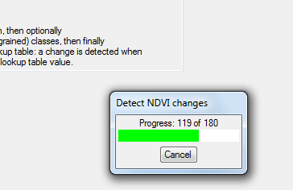
If a ROI is used with an irregular shape, the area outside the ROI will be given the no_data value -3000.0.

Remarks
The layers all get new names:
Image name New name Comment
2001_2_18.hdf 2001_049 the month and day are converted to a Julian day (in a year of 366 days)
<other>.hdf <other> Only the extension is removed

The new names are used as band names in case of stacking, and as filenames in case of separate files. In the last situation the (single) band in the image will be called ‘NDVI’
The statistics table is written in CSV text format, similar to:
layer,mean,stddev,min,max
2001_001, 0.364973, 0.127792, -0.198100, 0.757700
2001_018, 0.399615, 0.137173, -0.192800, 0.800700
2001_033, 0.441234, 0.141892, -0.187700, 0.839700
The layer name is used as the first column. The no_data value is not included in the statistics calculation. The file can be opened in Excel directly if the extension .CSV is used.

Screenshots
Fig 1: Form immediately after startup
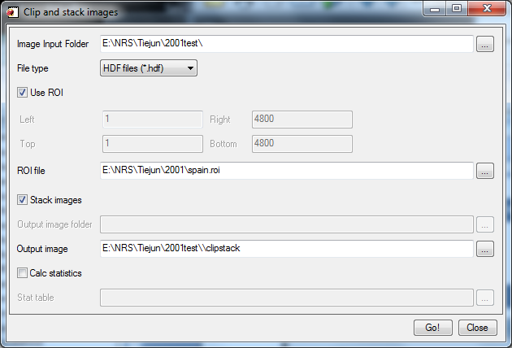
Fig 2: After selection of input folder and selection of ROI file

